Module 1: Get started with AI agent development on Azure
- Introduction:
  - In more complex scenarios, organisations can develop multi-agent solutions where multiple agents coordinate work between them. For instance, a travel booking agent could book flights and hotels for employees and automatically submit expense claims with appropriate receipts to the expense’s agent—creating an integrated workflow that spans multiple business processes.
  - AI agents are smart applications that use language models to understand what you need and then take action to help you.
  - 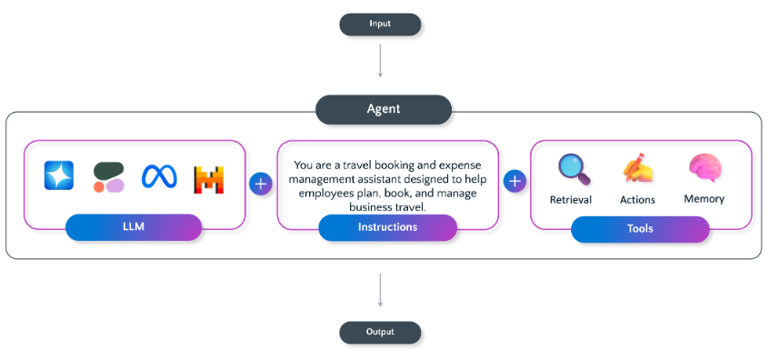

  - Agent's capabilities:
    - Knowledge integration and reasoning
    - Task automation through functions
    - Intelligent decision-making
  - As AI agents become more autonomous and integrated into enterprise systems, they introduce new security considerations that go beyond traditional application threats. Because agents can access sensitive data, make decisions, and act independently, developers and organizations must design with security in mind from the start.
    - Data leakage and privacy exposure
    - Prompt injection and manipulation attacks
    - Unauthorized access and privilege escalation
    - Data poisoning
    - Over-reliance on autonomous actions
    - Inadequate auditability and logging
    - Model inversion and output leakage
  - Protect your agents with security best practices:
    - Control access tightly: Enforce role-based access controls (RBAC) and least privilege permissions—agents should only access what they absolutely need.

- Options for agent development:
  - AI agents go beyond traditional apps that just respond to what you tell them—they can reason, act independently, learn, and work together to get things done. Building these proactive systems requires specialized frameworks and tools
  - Microsoft offers several solutions—from low-code tools for business users to full-featured SDKs for professional developers—each designed for different scenarios and skill levels.
    - Microsoft Foundry Agent Service
    - OpenAI Assistants API
    - Microsoft Agent Framework
    - AutoGen
    - Microsoft 365 agents SDK
    - Microsoft Copilot Studio
    - Copilot Studio lite experience in Microsoft 365 Copilot
Scenarios for when to use which agent framework:
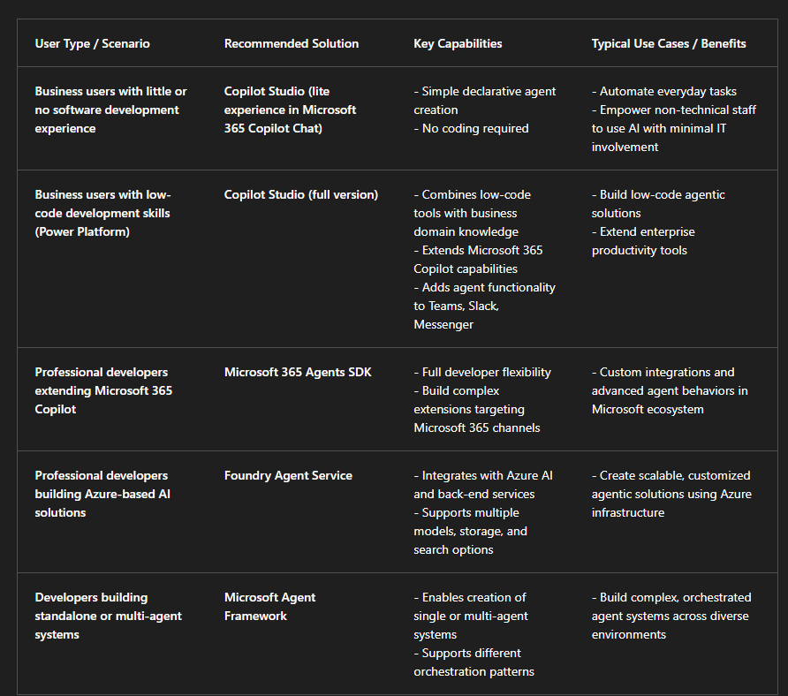

- Microsoft Foundry Agent Service:
  - Microsoft Foundry Agent Service is a service within Azure that you can use to create, test, and manage AI agents. It provides both a visual agent development experience in the Microsoft Foundry portal and a code-first development experience using the Microsoft Foundry SDK.
  - Components of an agent:
    - Model: A deployed generative AI model that enables the agent to reason and generate natural language responses to prompts. You can use common OpenAI models and a selection of models from the Microsoft Foundry model catalog.
    - Knowledge: Data sources that enable the agent to ground prompts with contextual data. Potential knowledge sources include Internet search results from Microsoft Bing, an Azure AI Search index, or your own data and documents.
    - Tools: Programmatic functions that enable the agent to automate actions. Built-in tools to access knowledge in Azure AI Search and Bing are provided as well as a code interpreter tool that you can use to generate and run Python code. You can also create custom tools using your own code or Azure Functions.
  - Conversations between users and agents take place on a thread, which retains a history of the messages exchanged in the conversation as well as any data assets, such as files, that are generated.
- Exercise: https://microsoftlearning.github.io/mslearn-ai-agents/Instructions/01-agent-fundamentals.html
- Module Assessment:
  - 